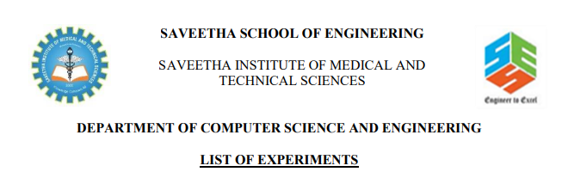COURSE CODE : CSA4053

Course NAME : MANAGEMENT INFORMATION SYSTEM

NAME :B.prasanth

Reg no:192110025

1) Draw a UML diagram for hotel reservation system. In a hotel reservation system, a customer can make online booking for a hotel, by specifying the accommodation requirements such as type of room (AC/Non-AC, One bed/two bed), total no of rooms, duration of stay. The system selects a suitable hotel as per customer’s requirements. If a hotel is found then the availability of rooms in that hotel is checked. The charges are calculated for the selected requirement and these are acknowledged to the customer. If the customer is satisfactory about the selection made by the system, then he confirms the reservation.

ANS: 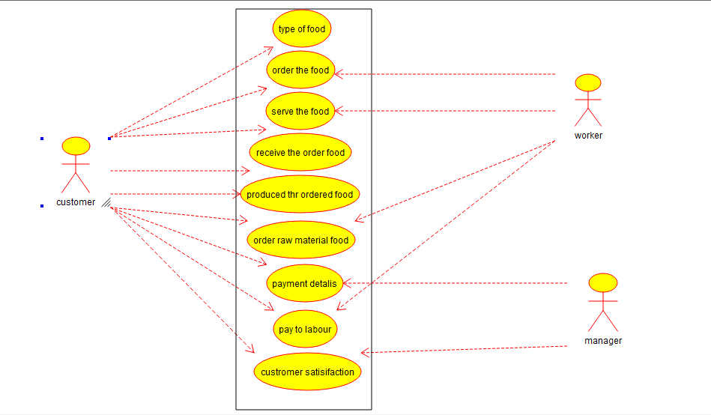

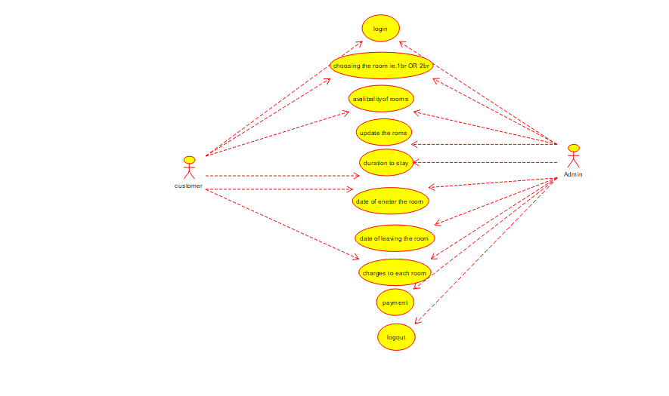

2) Draw a coffe coffe day ordering system. A coffe coffee day shop vending machine dispenses coffee to customers. Customers order coffee by selecting a recipe from a set of recipes. Customers pay for the coffee using coins. Change is given back, if any, to the customers. The ‘service assistant’ loads ingredients (coffee powder, milk, sugar, water, chocolate) into the coffee machine. The ‘service assistant’ adds recipe by indicating the name of the coffee, the units of coffee powder, milk, sugar, water, chocolate to be added as well as the cost of the coffee. The service assistant can also edit and delete a recipe. Develop the use case diagram for the specification above.

ANS:

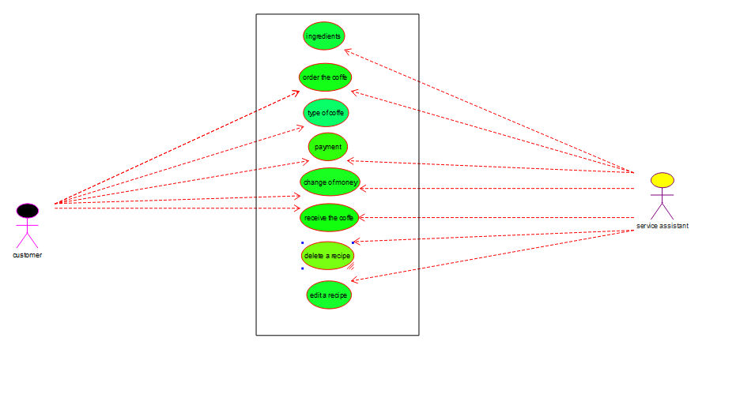

3) Make an Online Airline Reservation System. The activities of the Online Airline Reservation system are listed below user, admin, LOGIN, MANANGE CLASSES, MANANGE WAITING LIST, MANAGE HOLDS, MANAGE DEADLINES, LOGOUT, using this has a step-by-step process draw a CLASS diagram. Draw a Class diagram for Library Management System using CASE tools.

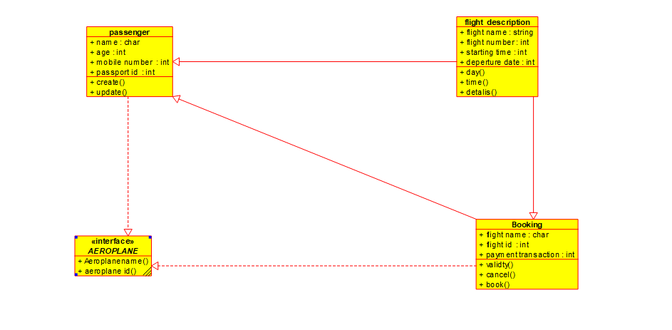

4. Draw a UML diagram for ATM System using CASE tool. The banking system allows a customer to access the financial transactions by ATM System, it has a step-by-step process describe the work of this process and elaborate the what are the work can do by customer, banking system, administrator and technicians with the ATM system.

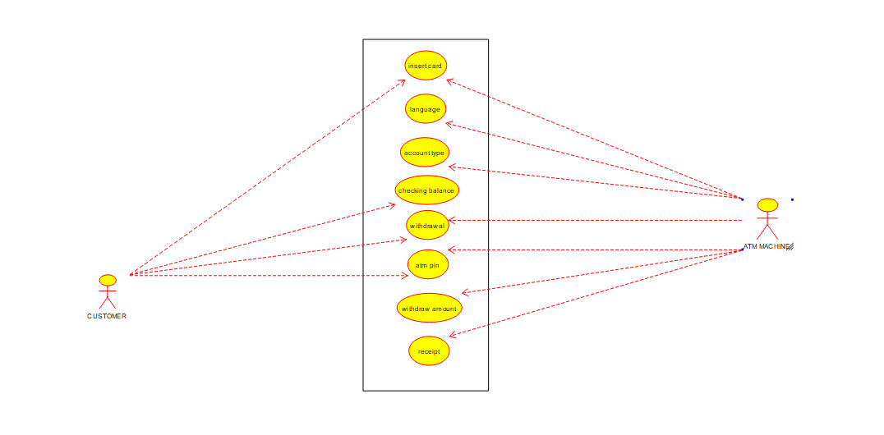

5) Draw a UML diagram for a food ordering system Systems. The activities of the food ordering system are listed below. Receive the Customer food orders, Produce the customer ordered food, Serve the customer with their ordered food, collect payment from Customers, Store customer payment details, Order Raw Materials for food products, Pay for Raw Materials and Pay for Labour. 